* **[How to edit a view](https://sharepoint.rackspace.com/Learning/Articles/Pages/SharePoint-2013--how-to-edit-a-view.aspx)**

In SharePoint 2013 views are extremely helpful in organizing your content to make it easier and quicker to find.  If you have already created a view but haven’t yet figured out how to edit it, you're in luck because that’s exactly what will be covered in this tutorial.   
  
1. From the home page of your SharePoint site, open any list or library you would like, in this example I will open my **Documents** library.  
  
2. At the top of the page click **LIBRARY**, to expand the ribbon.

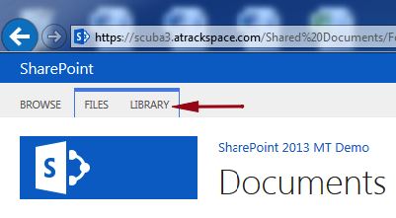

3. On the ribbon click Library Settings.

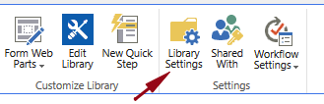  
  
4. On the Document Settings page scroll to the bottom and under the Views heading click the view you would like to edit, in this example **Reviewed**.

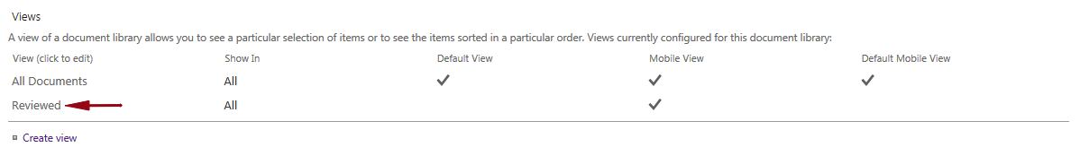

5. Check the box next to **Make this the default view**.

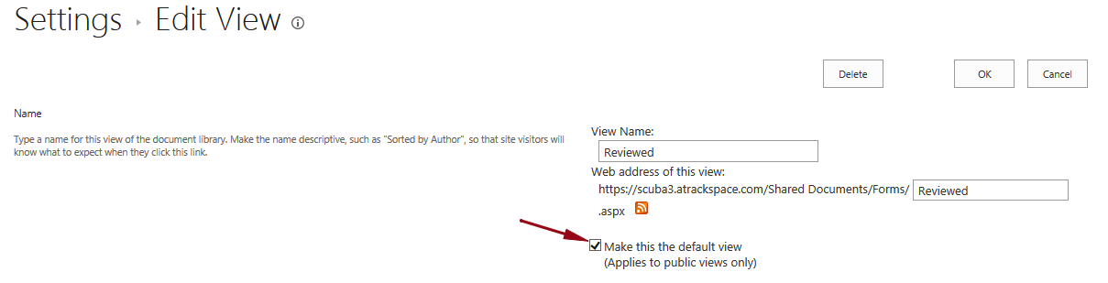

6. Check the box next to **Description** to add this column to the view.

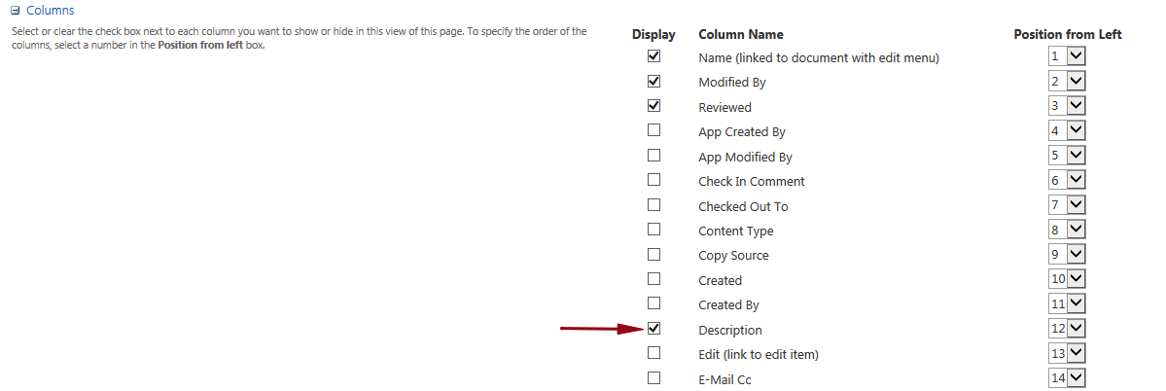

7. Review your changes or make any additional ones you would like and click **OK**.

https://sharepoint.rackspace.com/Learning/PublishingImages/How%20to%20edit%20a%20view/editdocview8.png

8. I will now see my Reviewed view in front of the All Documents view (which means it is set as the default view) as well as a Description column.

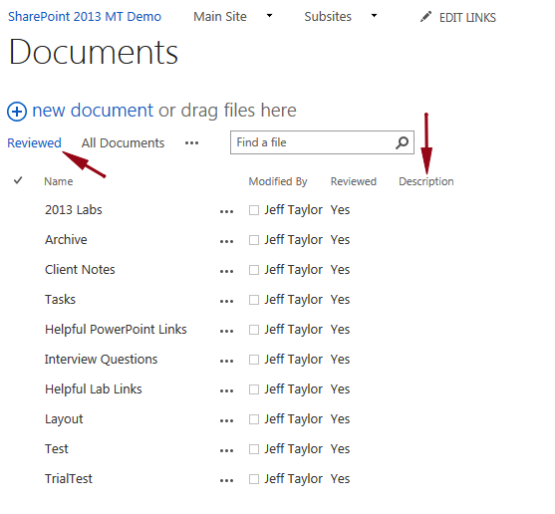

These were just a few basic changes to my view.  Now that you know how to edit a view you can go in and make several other changes.